**5-2: Create a WBS for one of the following projects:**

* **Introducing self-checkout registers at the school bookstore**
* **Updating 50 laptops from Windows 7 to Windows 10**
* **Providing a new internet cafe onsite at your organization**
* **Developing an app to sell online**
* **Earning your PMP certification**

**Decide on all level 1 and 2 categories.  Create a level 3 for at least one level 2 activity. Use your choice of software to create the WBS in chart form. Share any questions you had while completing this exercise.**

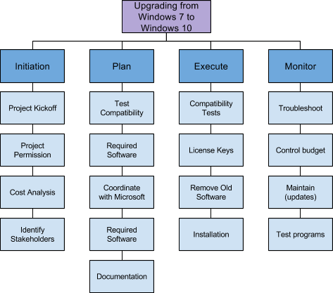

Brian Batinchok

CIS4524 Discussion 5-2